|  |  |  |  |
| --- | --- | --- | --- |
| 1 | | 19,032.0 | |
| NUMERO DE FRONTERAS | | ENERGIA AGREGADA | |
|  | | | |
| SI | | 0 | |
| CONTRATO | | VENCIMIENTO CONTRATO | |
|  | | | |
| 62,842,941 | 150 | | 2,580,855 |
| INGRESO 2020 | DÍAS CERTIFICADOS 2020 | | ENERGIA RESPALDADA 2020 |
|  | | | |
| 62,637,264 | 142 | | 2,702,273 |
| INGRESO 2021 | DÍAS CERTIFICADOS 2021 | | ENERGIA RESPALDADA 2021 |

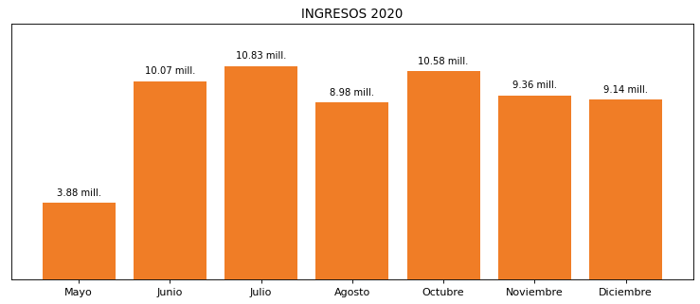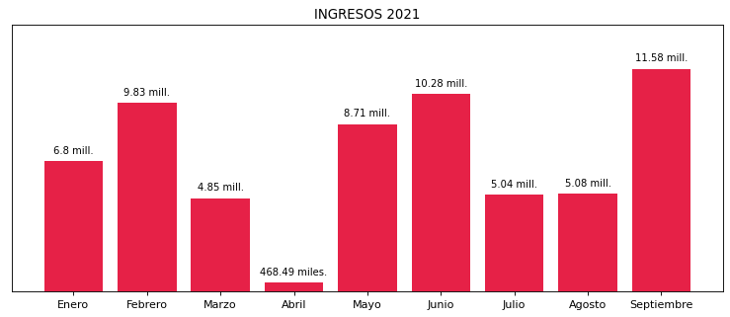

|  |
| --- |
| **ALBATEQ HARINAS**  USUARIO |

|  |
| --- |
| **Mateo Porras**  Ejecutivo de cuenta |

|  |
| --- |
| **0**  PUNTO FOCAL |

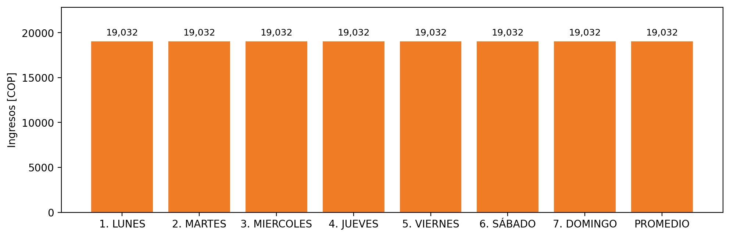

|  |  |  |  |  |  |  |  |  |  |  |
| --- | --- | --- | --- | --- | --- | --- | --- | --- | --- | --- |
| **FRONTERA** | **COD SIC** | **PREDIO** | **FRT DDV** | **TIPO DDV** | **PROMEDIO** | **PRÓXIMA ACTUALIZACIÓN** | **MARGEN DE ERROR** | **ÚLTIMA PRUEBA DDV** | **DÍAS PARTICIPACIÓN** | **FECHA REFERENCIA PRÓXIMA PRUEBA DDV** |
| ALIMENTOS BALANCEADOS TEQUENDAMA S.A. - BALSILLAS | Frt07836 | Prd02108 | Frt39047 | GPE | 19,032 | 2026-04-15 | NO APLICA | 2021-07-23 | 37.0 | 2021-12-29 |